🌿 MongoDB


Practical 01 –
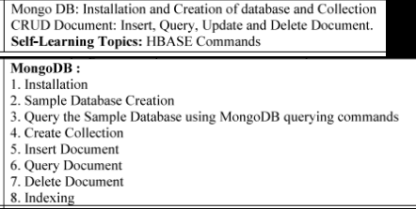
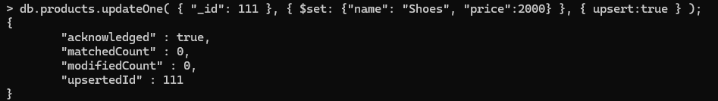
$inc → increment

QUESTIONS:
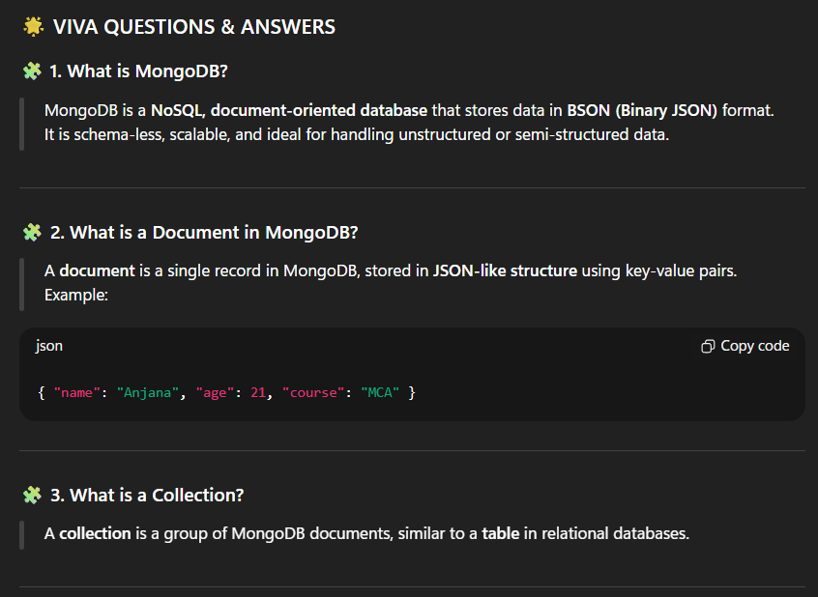

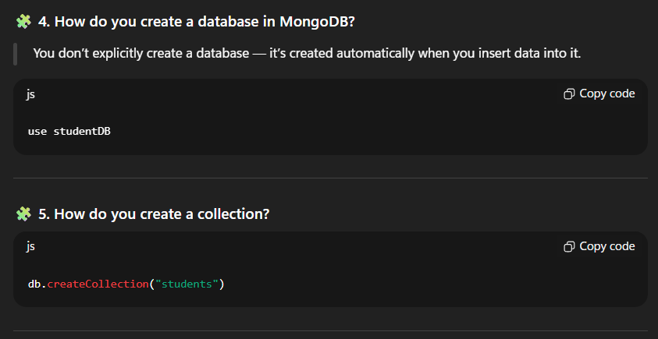
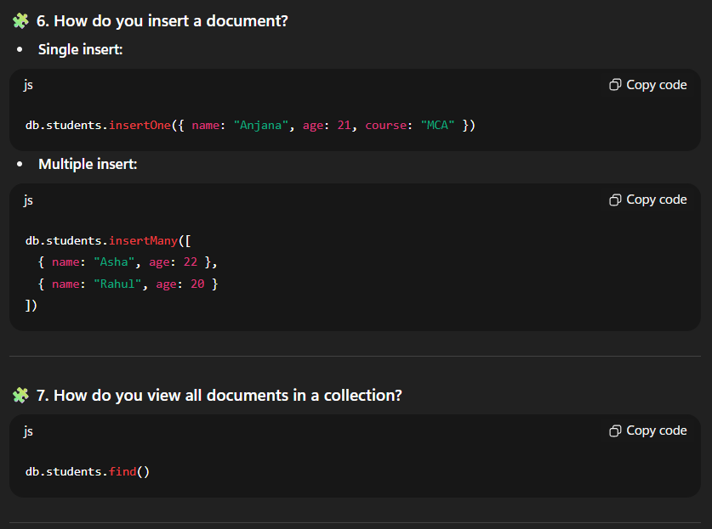

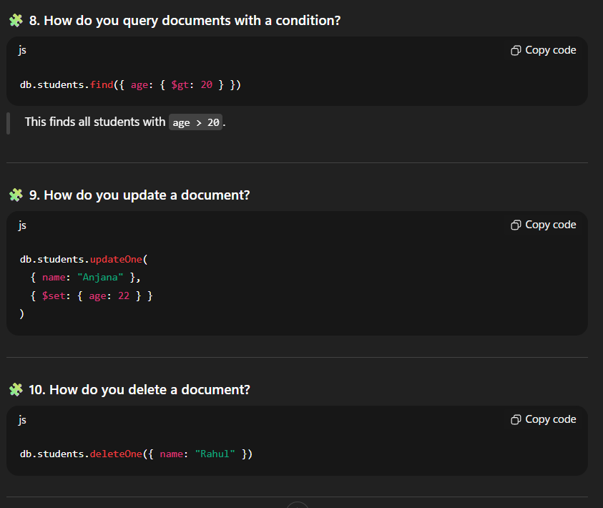
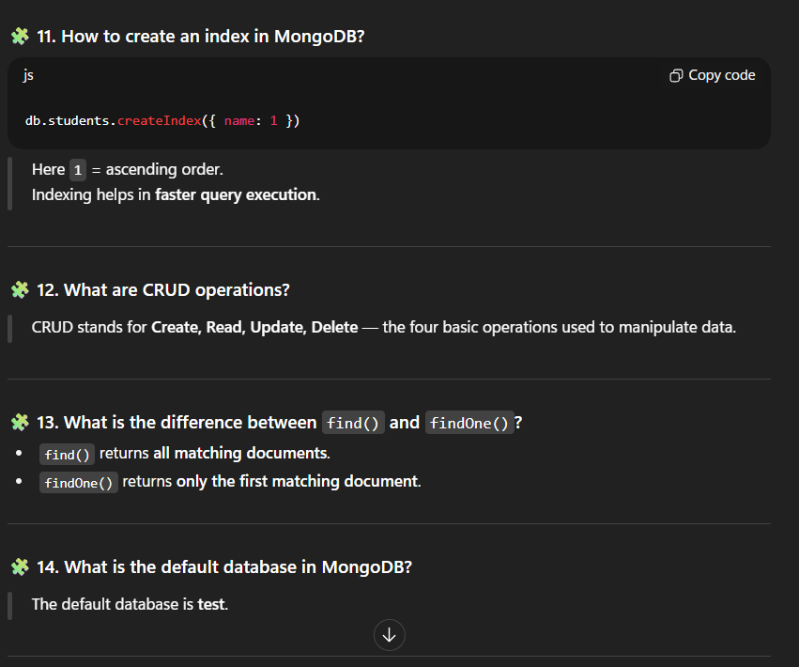
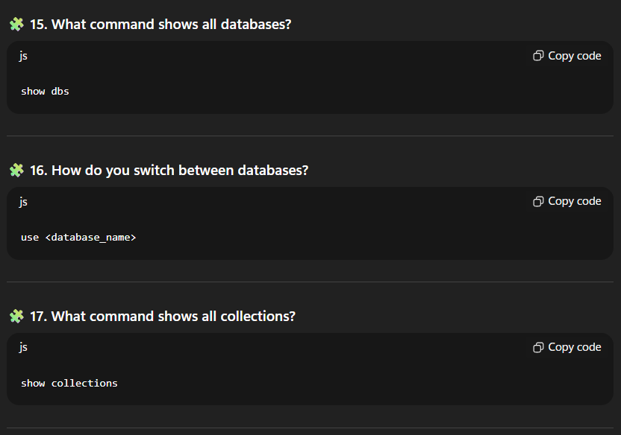
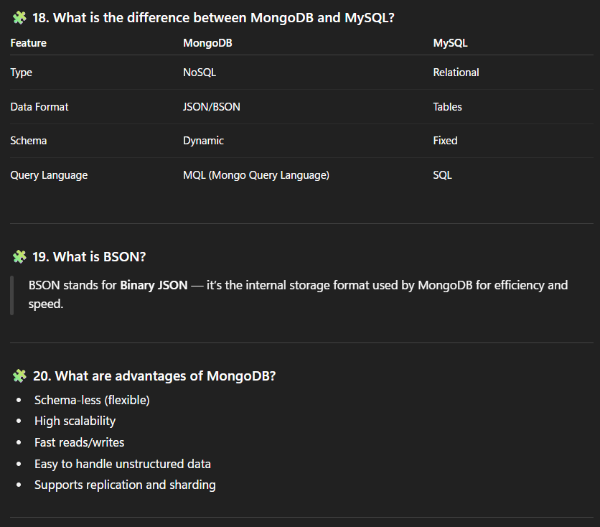
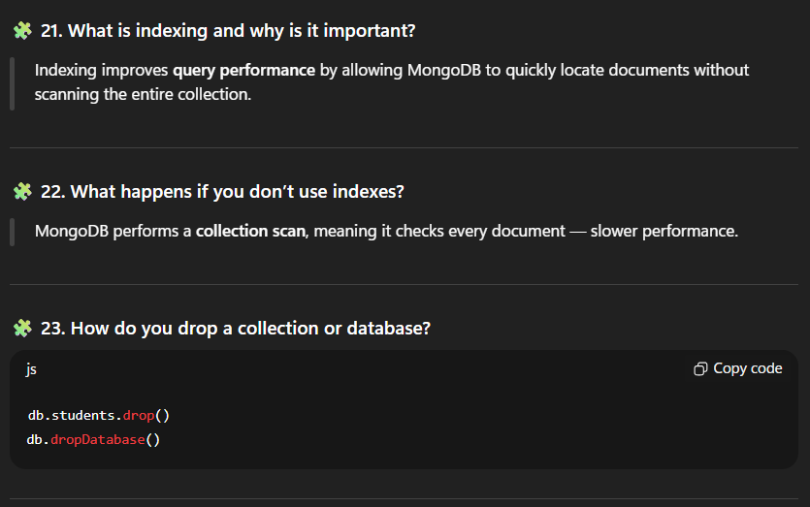
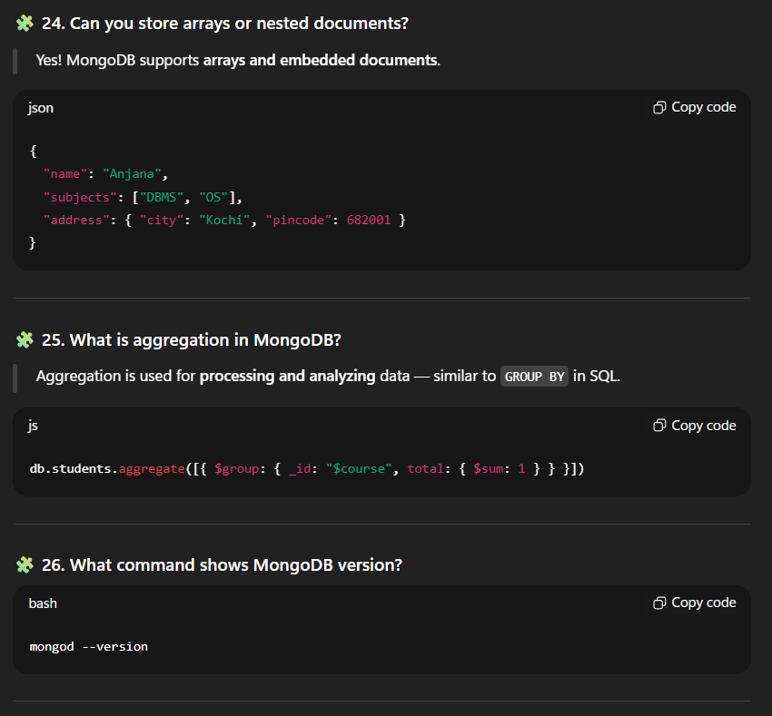
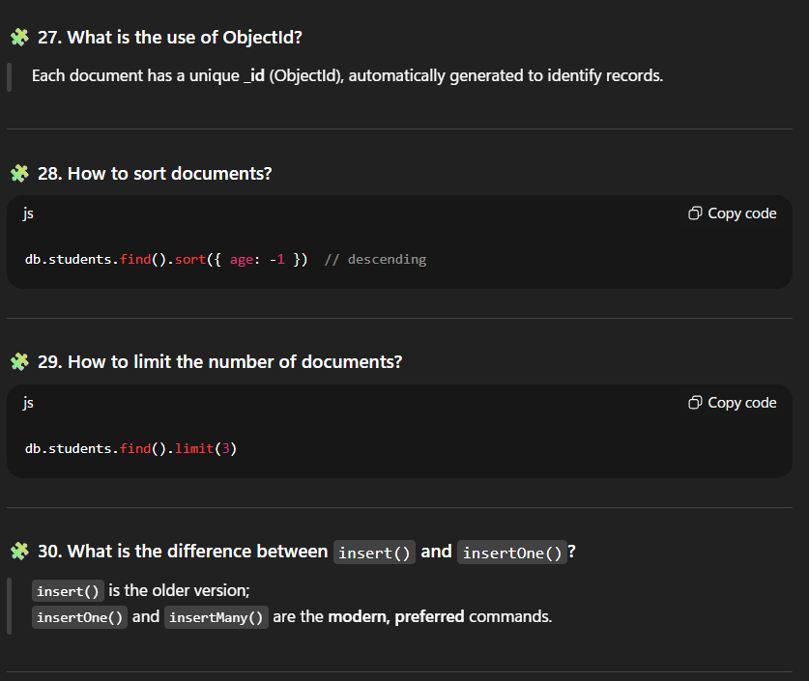

CODE:
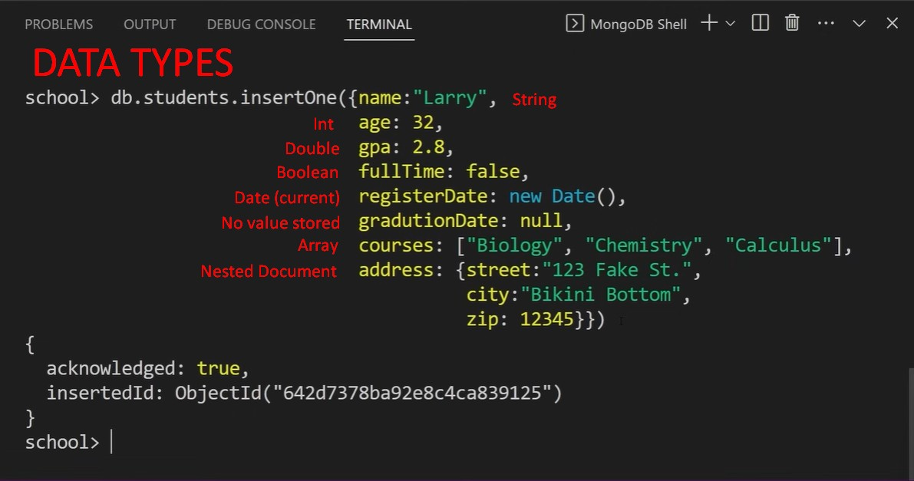

Using .find({query}{projection})
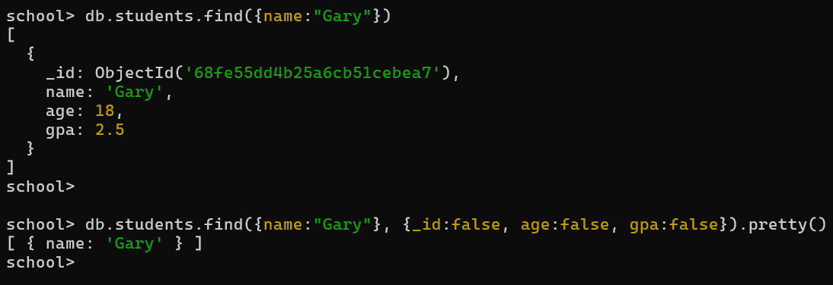

📊TABLEAU

📊TABLEAU

1. What is Tableau?
A data visualization tool that converts raw data into interactive dashboards and charts without coding.

2. Why use Tableau?
- Easy drag-and-drop interface
- Connects to multiple data sources
- Creates interactive visualizations quickly
- Sharing through Tableau Server/Public

3. Types of Tableau products?
- Tableau Desktop - Create visualizations
- Tableau Server - Share dashboards (on-premise)
- Tableau Online - Cloud-based sharing
- Tableau Public - Free, public sharing

4. What data sources can Tableau connect to?
Excel, CSV, SQL databases, Google Sheets, cloud databases, web data connectors.

5. Difference between Live Connection vs Extract?
- Live - Real-time data from source (slower)
- Extract - Snapshot/copy of data (faster performance)

6. What are Dimensions and Measures?
- Dimensions - Categorical data (text, dates) - answers "what"
- Measures - Numerical data (quantities) - answers "how much"

7. Common chart types in Tableau?
Bar, Line, Pie, Scatter, Heat map, Tree map, Area, Bullet, Gantt.

8. What is a Dashboard?
Collection of multiple worksheets/visualizations on one screen for comprehensive analysis.

9. Difference between Dashboard and Story?
- Dashboard - Multiple charts together, interactive
- Story - Sequence of dashboards/sheets with narrative flow (presentation mode)

10. What are Filters?
Limit data shown in visualizations - can be dimension filters, measure filters, or date filters.

11. What is Show Me panel?
Suggests appropriate chart types based on selected fields.

12. How to create calculated fields?
Right-click in data pane → Create Calculated Field → Write formula.

13. What are Marks cards?
Controls visual properties: Color, Size, Label, Detail, Tooltip, Shape.

14. How to create maps in Tableau?
Use geographic fields (Country, State, City) → Tableau auto-generates latitude/longitude → Creates map visualization.

15. What are Sheets, Dashboards, and Stories?
- Sheet - Single visualization (worksheet)
- Dashboard - Multiple sheets combined
- Story - Series of dashboards with narrative

16. What is Data Blending?
Combining data from multiple sources in one visualization (like a JOIN).

17. What are parameters?
Dynamic values that users can change to affect calculations or filters.

18. Difference between Tableau Desktop and Tableau Public?
- Desktop - Paid, save locally, connect to any data source
- Public - Free, saves to cloud publicly, limited data sources

19. How to share Tableau visualizations?
Export as image/PDF, publish to Tableau Server/Online/Public, embed in websites.

20. What is dual-axis chart?
Two measures plotted on same chart with separate axes for comparison.

Quick Demo Flow:
- Import → Connect to data source
- Analyze → Drag dimensions/measures to create charts
- Dashboard → Combine multiple sheets
- Maps → Use geographic fields
- Story → Create narrative with story points
- Publish → Share visualization
Pro tip: Always mention "drag-and-drop" and "no coding required" - that's Tableau's main selling point! 🎯

🖥️HDFS

HDFS
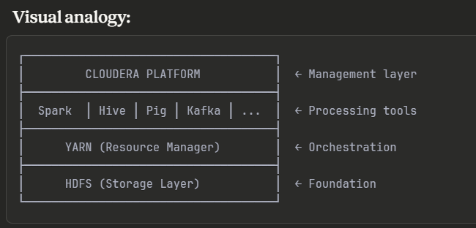
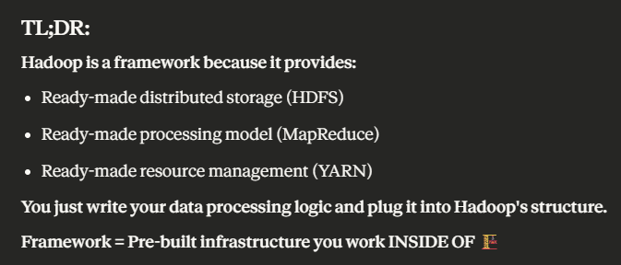
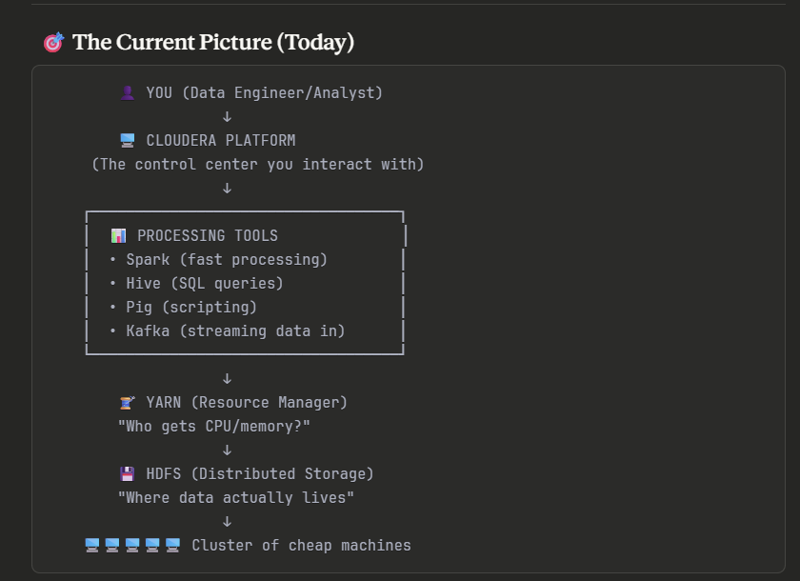
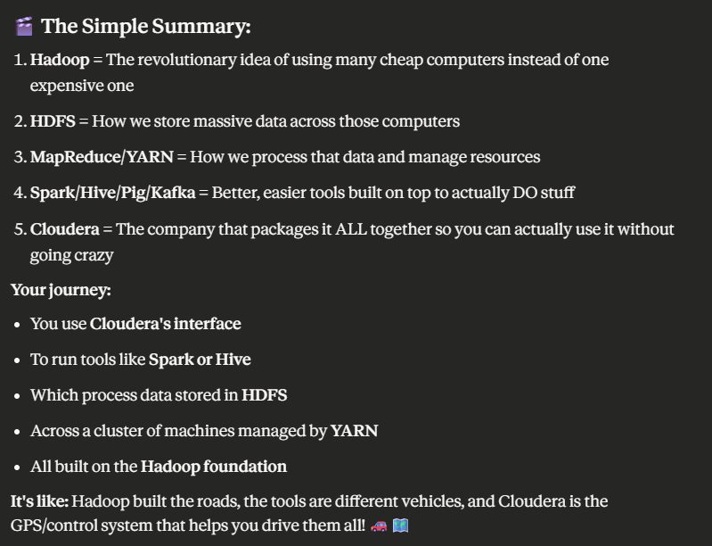
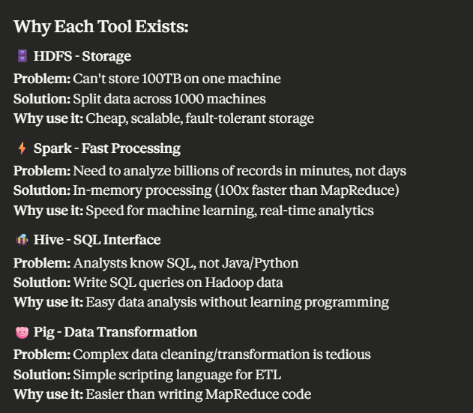
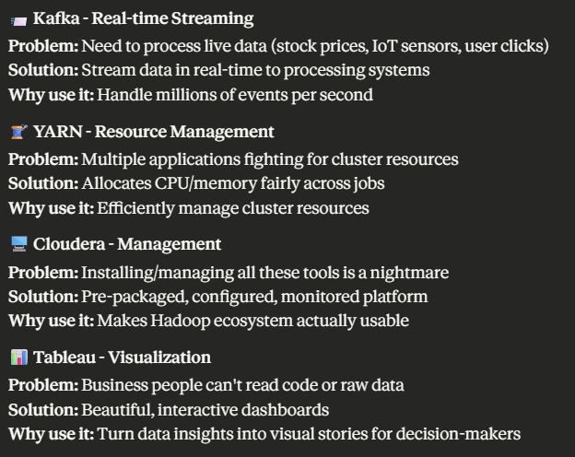
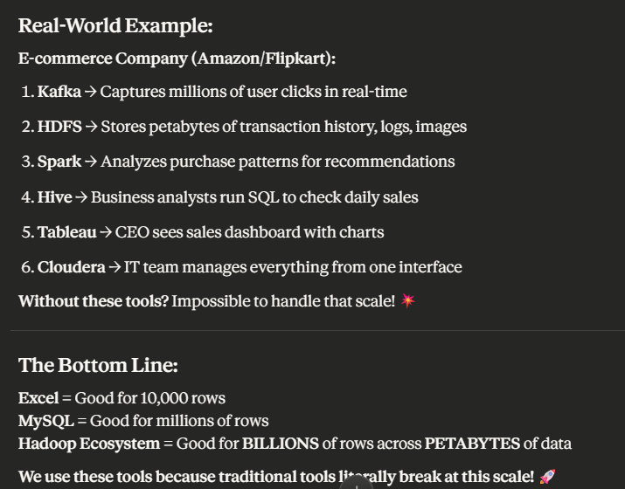

🐝 HIVE

🐝 HIVE VIVA Questions & Answers

1. HIVE DATA TYPES

Q1: What are the basic data types in Hive?
A:
- Numeric: TINYINT, SMALLINT, INT, BIGINT, FLOAT, DOUBLE, DECIMAL
- String: STRING, VARCHAR, CHAR
- Date/Time: DATE, TIMESTAMP
- Boolean: BOOLEAN
- Binary: BINARY

Q2: What are complex data types in Hive?
A:
- ARRAY - Ordered collection: ARRAY<INT>
- MAP - Key-value pairs: MAP<STRING, INT>
- STRUCT - Named fields: STRUCT<name:STRING, age:INT>
- UNIONTYPE - One of several types

Q3: Difference between STRING and VARCHAR?
A:
- STRING: Variable length, no limit
- VARCHAR(n): Variable length with max limit 'n'
- CHAR(n): Fixed length 'n', pads with spaces

2. CREATE DATABASE & TABLE

Q4: How to create a database in Hive?
A:
CREATE DATABASE company;
CREATE DATABASE IF NOT EXISTS company;

Q5: How to create a table in Hive?
A:
CREATE TABLE employee (
id INT,
name STRING,
salary FLOAT,
dept STRING
)
ROW FORMAT DELIMITED
FIELDS TERMINATED BY ','
STORED AS TEXTFILE;

Q6: How to create an external table?
A:
CREATE EXTERNAL TABLE emp_external (
id INT,
name STRING
)
LOCATION '/user/data/emp/';

Q7: Difference between Internal and External table?
A:
- Internal (Managed): Hive manages data; DROP deletes data
- External: Hive only manages metadata; DROP keeps data in HDFS

Q8: How to load data into Hive table?
A:
LOAD DATA LOCAL INPATH '/home/user/emp.csv' INTO TABLE employee;
-- Or from HDFS:
LOAD DATA INPATH '/user/hive/emp.csv' INTO TABLE employee;

3. HIVE PARTITIONING

Q9: What is partitioning in Hive?
A: Dividing table data into subdirectories based on column values to improve query performance by scanning only relevant partitions.

Q10: How to create a partitioned table?
A:
CREATE TABLE sales (
id INT,
product STRING,
amount FLOAT
)
PARTITIONED BY (year INT, month INT);

Q11: How to load data into partitioned table?
A:
LOAD DATA LOCAL INPATH '/data/sales.csv'
INTO TABLE sales
PARTITION (year=2024, month=11);

Q12: Types of partitioning?
A:
- Static Partitioning: Manually specify partition values
- Dynamic Partitioning: Hive automatically creates partitions based on data

Q13: Dynamic partitioning example?
A:
SET hive.exec.dynamic.partition=true;
SET hive.exec.dynamic.partition.mode=nonstrict;

INSERT INTO TABLE sales PARTITION(year, month)
SELECT id, product, amount, year, month FROM temp_sales;

Q14: What is bucketing?
A: Further dividing data within partitions into fixed number of files based on hash of a column for better query performance and sampling.

4. HIVE BUILT-IN OPERATORS

Q15: What are relational operators in Hive?
A:
- = (equal), != or <> (not equal)
- <, >, <=, >=
- IS NULL, IS NOT NULL
- BETWEEN, IN, LIKE

Q16: What are logical operators?
A:
- AND, OR, NOT

Q17: What are arithmetic operators?
A:
- +, -, *, /, % (modulo)

Q18: Example of LIKE operator?
A:
SELECT * FROM employee WHERE name LIKE 'A%'; -- Starts with A
SELECT * FROM employee WHERE name LIKE '%kumar'; -- Ends with kumar
SELECT * FROM employee WHERE name LIKE '%an%'; -- Contains an

5. HIVE BUILT-IN FUNCTIONS

Q19: What are aggregate functions in Hive?
A:
- COUNT(), SUM(), AVG(), MIN(), MAX()
- STDDEV_POP(), STDDEV_SAMP(), VAR_POP(), VAR_SAMP()

Q20: What are string functions?
A:
- CONCAT(), SUBSTR(), UPPER(), LOWER()
- LENGTH(), TRIM(), REVERSE(), SPLIT()

Q21: What are date functions?
A:
- YEAR(), MONTH(), DAY(), HOUR()
- DATE_ADD(), DATE_SUB(), DATEDIFF()
- CURRENT_DATE(), CURRENT_TIMESTAMP()

Q22: Example of CONCAT function?
A:
SELECT CONCAT(first_name, ' ', last_name) AS full_name FROM employee;

Q23: What are mathematical functions?
A:
- ROUND(), FLOOR(), CEIL(), ABS()
- SQRT(), POW(), RAND()

Q24: Example of date functions?
A:
SELECT YEAR(hire_date), MONTH(hire_date) FROM employee;
SELECT DATEDIFF(CURRENT_DATE(), hire_date) AS days_employed FROM employee;

6. HIVE VIEWS

Q25: What is a view in Hive?
A: A virtual table based on a SELECT query. Doesn't store data, only stores the query definition.

Q26: How to create a view?
A:
CREATE VIEW high_salary_emp AS
SELECT * FROM employee WHERE salary > 50000;

Q27: Advantages of views?
A:
- Simplifies complex queries
- Security (hide sensitive columns)
- Reusability
- Logical data independence

Q28: How to drop a view?
A:
DROP VIEW IF EXISTS high_salary_emp;

Q29: Can we insert data into a view?
A: No, Hive views are read-only. You cannot INSERT/UPDATE/DELETE through views.

7. HiveQL: SELECT OPERATIONS

Q30: Basic SELECT query?
A:
SELECT * FROM employee;
SELECT name, salary FROM employee;

SELECT WHERE

Q31: SELECT with WHERE clause?
A:
SELECT * FROM employee WHERE salary > 50000;
SELECT * FROM employee WHERE dept = 'IT' AND salary > 40000;

Q32: WHERE with multiple conditions?
A:
SELECT * FROM employee
WHERE dept IN ('IT', 'HR') AND salary BETWEEN 30000 AND 60000;

SELECT ORDER BY

Q33: How to sort results?
A:
-- Ascending (default)
SELECT * FROM employee ORDER BY salary;

-- Descending
SELECT * FROM employee ORDER BY salary DESC;

-- Multiple columns
SELECT * FROM employee ORDER BY dept, salary DESC;

Q34: Difference between ORDER BY and SORT BY?
A:
- ORDER BY: Global sorting (single reducer, slower)
- SORT BY: Local sorting per reducer (faster but not globally sorted)

SELECT GROUP BY

Q35: What is GROUP BY?
A: Groups rows with same values and applies aggregate functions.

Q36: GROUP BY example?
A:
-- Average salary by department
SELECT dept, AVG(salary) FROM employee GROUP BY dept;

-- Count employees per department
SELECT dept, COUNT(*) FROM employee GROUP BY dept;

Q37: GROUP BY with HAVING?
A:
-- Departments with more than 5 employees
SELECT dept, COUNT(*) as emp_count
FROM employee
GROUP BY dept
HAVING COUNT(*) > 5;

Q38: Difference between WHERE and HAVING?
A:
- WHERE: Filters rows BEFORE grouping
- HAVING: Filters groups AFTER grouping
- HAVING is used with aggregate functions

SELECT JOINS

Q39: Types of joins in Hive?
A:
- INNER JOIN: Returns matching rows from both tables
- LEFT OUTER JOIN: All from left + matching from right
- RIGHT OUTER JOIN: All from right + matching from left
- FULL OUTER JOIN: All rows from both tables
- CROSS JOIN: Cartesian product

Q40: INNER JOIN example?
A:
SELECT e.name, e.salary, d.dept_name
FROM employee e
INNER JOIN department d ON e.dept_id = d.dept_id;

Q41: LEFT JOIN example?
A:
SELECT e.name, d.dept_name
FROM employee e
LEFT JOIN department d ON e.dept_id = d.dept_id;
-- Returns all employees, even without department

Q42: Self JOIN example?
A:
-- Find employees and their managers
SELECT e1.name AS employee, e2.name AS manager
FROM employee e1
JOIN employee e2 ON e1.manager_id = e2.id;

Q43: JOIN with WHERE?
A:
SELECT e.name, d.dept_name
FROM employee e
JOIN department d ON e.dept_id = d.dept_id
WHERE e.salary > 50000;

BONUS QUESTIONS

Q44: What is the difference between Hive and traditional RDBMS?
A:
- Hive: Schema-on-read, HDFS storage, batch processing, SQL-like (HiveQL)
- RDBMS: Schema-on-write, disk storage, real-time queries, standard SQL

Q45: What is SerDe in Hive?
A: Serializer/Deserializer - converts data between table format and storage format (CSV, JSON, Parquet, etc.)

Q46: What is metastore in Hive?
A: Central repository storing metadata (table schemas, partitions, locations) - usually stored in MySQL/Derby database.

Q47: Can Hive handle real-time queries?
A: No, Hive is designed for batch processing. For real-time, use tools like Impala or Presto.

Q48: What file formats does Hive support?
A: TEXTFILE, SEQUENCEFILE, ORC, PARQUET, AVRO, RCFILE

Quick Command Reference:
-- Database operations
SHOW DATABASES;
USE database_name;
DROP DATABASE database_name;

-- Table operations
SHOW TABLES;
DESCRIBE table_name;
DESCRIBE FORMATTED table_name;
DROP TABLE table_name;

-- Partition operations
SHOW PARTITIONS table_name;
ALTER TABLE table_name ADD PARTITION(year=2024);

Pro Tip for Viva: Always mention "Hive converts queries to MapReduce/Tez jobs" when explaining how Hive works! 🎯

🐷 PIG

🐷 PIG VIVA Questions & Answers

1. PIG LATIN BASICS

Q1: What is Pig?
A: Pig is a high-level platform for processing large datasets in Hadoop using a scripting language called Pig Latin. It simplifies MapReduce programming.

Q2: What is Pig Latin?
A: Pig Latin is a data flow scripting language used in Pig to write data analysis programs. It's simpler than writing Java MapReduce code.

Q3: Why use Pig instead of MapReduce?
A:
- Easier: 10 lines of Pig Latin = 200 lines of Java MapReduce
- Faster development: Quick to write and test
- Automatic optimization: Pig optimizes execution
- Less code: More productivity

Q4: What are the execution modes in Pig?
A:
- Local Mode: Runs on single machine, processes local files (pig -x local)
- MapReduce Mode: Runs on Hadoop cluster, processes HDFS files (pig -x mapreduce)

Q5: What is Grunt shell?
A: Interactive shell for executing Pig Latin commands one at a time. Start with pig command.

Q6: Key features of Pig?
A:
- Easy to learn
- Automatic optimization
- Extensibility (User Defined Functions)
- Handles structured and semi-structured data
- ETL (Extract, Transform, Load) operations

2. PIG DATA TYPES

Q7: What are scalar data types in Pig?
A:
- int - 32-bit integer
- long - 64-bit integer
- float - 32-bit floating point
- double - 64-bit floating point
- chararray - String (UTF-8)
- bytearray - Blob (binary)
- boolean - true/false
- datetime - Date and time

Q8: What are complex data types in Pig?
A:
- Tuple: Ordered set of fields (value1, value2, value3)
- Bag: Collection of tuples {(1,'a'), (2,'b')}
- Map: Key-value pairs [key1#value1, key2#value2]

Q9: Example of tuple?
A:
-- Tuple with 3 fields
(John, 25, Engineer)
-- Access: $0 = John, $1 = 25, $2 = Engineer

Q10: Example of bag?
A:
-- Bag containing multiple tuples
{(1, 'Apple'), (2, 'Banana'), (3, 'Orange')}

Q11: Example of map?
A:
-- Map with key-value pairs
[name#John, age#25, city#Mumbai]
-- Access: data#'name' returns 'John'

3. DOWNLOAD THE DATA

Q12: How to load data from local file system?
A:
-- Local mode
data = LOAD '/home/user/employee.txt' USING PigStorage(',')
AS (id:int, name:chararray, salary:float);

Q13: How to load data from HDFS?
A:
-- MapReduce mode
data = LOAD '/user/hadoop/employee.txt' USING PigStorage(',')
AS (id:int, name:chararray, salary:float);

Q14: What is PigStorage()?
A: Default loader function that loads structured text files. Parameter specifies delimiter (default is tab \t).

Q15: How to load data without schema?
A:
-- Load without defining schema (all fields become bytearray)
data = LOAD '/user/data/file.txt';

Q16: Other loader functions?
A:
- TextLoader: Loads unstructured text files
- JsonLoader: Loads JSON files
- AvroStorage: Loads Avro files
- ParquetLoader: Loads Parquet files

4. CREATE YOUR SCRIPT

Q17: How to create a Pig script?
A: Write Pig Latin commands in a text file with .pig extension:
nano employee_analysis.pig
# or
vi employee_analysis.pig

Q18: Sample Pig script structure?
A:
-- Load data
employees = LOAD '/data/emp.txt' USING PigStorage(',')
AS (id:int, name:chararray, dept:chararray, salary:float);

-- Filter high salary employees
high_sal = FILTER employees BY salary > 50000;

-- Group by department
dept_group = GROUP high_sal BY dept;

-- Count per department
dept_count = FOREACH dept_group GENERATE group, COUNT(high_sal);

-- Store results
STORE dept_count INTO '/output/result' USING PigStorage(',');

Q19: What are comments in Pig?
A:
-- This is a single line comment
/* This is a
multi-line comment */

5. SAVE AND EXECUTE THE SCRIPT

Q20: How to execute a Pig script?
A:
# Local mode
pig -x local employee_analysis.pig

# MapReduce mode (on Hadoop cluster)
pig -x mapreduce employee_analysis.pig
# or simply
pig employee_analysis.pig

Q21: How to save results/output?
A:
-- Store to HDFS
STORE result INTO '/user/output/results' USING PigStorage(',');

-- Store to local filesystem
STORE result INTO '/home/user/results' USING PigStorage(',');

Q22: How to check script syntax without execution?
A:
pig -check employee_analysis.pig

Q23: How to run Pig in interactive mode?
A:
# Start Grunt shell
pig

# Then type commands interactively
grunt> data = LOAD '/data/file.txt';
grunt> dump data;

6. PIG OPERATIONS

A. DIAGNOSTIC OPERATORS

Q24: What are diagnostic operators?
A: Operators used to debug and verify data during development.

Q25: DUMP operator?
A: Displays output on screen (for debugging).
employees = LOAD '/data/emp.txt' AS (id:int, name:chararray);
DUMP employees; -- Shows all records on console

Q26: DESCRIBE operator?
A: Shows schema of a relation.
DESCRIBE employees;
-- Output: employees: {id: int, name: chararray, salary: float}

Q27: EXPLAIN operator?
A: Shows execution plan (logical, physical, MapReduce plans).
EXPLAIN employees;

Q28: ILLUSTRATE operator?
A: Shows step-by-step execution with sample data.
ILLUSTRATE employees;

B. GROUPING AND JOINING

Q29: GROUP BY operator?
A: Groups data by one or more fields.
-- Group employees by department
dept_group = GROUP employees BY dept;

-- Group by multiple fields
multi_group = GROUP employees BY (dept, location);

Q30: What does GROUP BY return?
A: Returns a bag with:
- group: The grouping key
- relation_name: Bag of all tuples in that group

Q31: COGROUP operator?
A: Groups data from multiple relations.
cg = COGROUP employees BY dept, departments BY dept_id;

Q32: JOIN types in Pig?
A:
- INNER JOIN: Matching records only
- LEFT OUTER JOIN: All from left + matching from right
- RIGHT OUTER JOIN: All from right + matching from left
- FULL OUTER JOIN: All from both

Q33: INNER JOIN example?
A:
result = JOIN employees BY dept_id, departments BY id;

Q34: LEFT JOIN example?
A:
result = JOIN employees BY dept_id LEFT OUTER, departments BY id;

Q35: CROSS operator?
A: Cartesian product of two relations.
cross_result = CROSS employees, departments;

C. COMBINING & SPLITTING

Q36: UNION operator?
A: Combines two or more relations (must have same schema).
all_data = UNION employees1, employees2, employees3;

Q37: SPLIT operator?
A: Splits one relation into multiple based on conditions.
SPLIT employees INTO
high_sal IF salary > 50000,
low_sal IF salary <= 50000;

Q38: Another SPLIT example?
A:
SPLIT students INTO
passed IF marks >= 40,
failed IF marks < 40,
distinction IF marks >= 75;

D. FILTERING

Q39: FILTER operator?
A: Selects tuples based on condition.
-- Single condition
high_sal = FILTER employees BY salary > 50000;

-- Multiple conditions
result = FILTER employees BY salary > 40000 AND dept == 'IT';

Q40: FILTER with complex conditions?
A:
-- Using OR
result = FILTER employees BY dept == 'IT' OR dept == 'HR';

-- Using IN
result = FILTER employees BY dept IN ('IT', 'HR', 'Finance');

-- Using NOT
result = FILTER employees BY NOT (salary < 30000);

Q41: DISTINCT operator?
A: Removes duplicate tuples.
unique_depts = DISTINCT (FOREACH employees GENERATE dept);

Q42: LIMIT operator?
A: Limits output to specified number of tuples.
top_10 = LIMIT employees 10;

Q43: SAMPLE operator?
A: Random sampling of data.
sample_data = SAMPLE employees 0.1; -- 10% random sample

E. SORTING

Q44: ORDER BY operator?
A: Sorts data in ascending or descending order.
-- Ascending (default)
sorted = ORDER employees BY salary;

-- Descending
sorted = ORDER employees BY salary DESC;

-- Multiple columns
sorted = ORDER employees BY dept ASC, salary DESC;

Q45: Difference between ORDER BY and SORT BY?
A:
- ORDER BY: Global sorting (guaranteed total order)
- No SORT BY in Pig (unlike Hive)

ADDITIONAL OPERATIONS

Q46: FOREACH...GENERATE?
A: Transforms data, like SELECT in SQL.
-- Select specific columns
result = FOREACH employees GENERATE id, name, salary;

-- With calculations
result = FOREACH employees GENERATE name, salary, salary*0.1 AS bonus;

Q47: FLATTEN operator?
A: Removes nesting from bags and tuples.
-- Before: {(1,2), (3,4)}
-- After FLATTEN: 1,2,3,4

result = FOREACH data GENERATE FLATTEN(bag_column);

Q48: Nested FOREACH?
A:
dept_stats = FOREACH (GROUP employees BY dept) {
high_sal = FILTER employees BY salary > 50000;
GENERATE group, COUNT(high_sal) AS high_sal_count;
}

COMPARISON: PIG vs HIVE vs MapReduce

Q49: When to use Pig vs Hive?
A:
- Use Pig: Complex ETL, data pipelines, procedural logic
- Use Hive: SQL-like queries, reports, data warehousing
- Both convert to MapReduce jobs

Q50: Pig vs MapReduce advantages?
A:
Pig | MapReduce
10 lines of code | 200 lines of code
Easy to learn | Complex Java code
Faster development | Time-consuming
Automatic optimization | Manual optimization

PRACTICAL COMMANDS SUMMARY
-- Load
data = LOAD '/path/file.txt' USING PigStorage(',') AS (id:int, name:chararray);

-- Filter
filtered = FILTER data BY salary > 50000;

-- Group
grouped = GROUP data BY dept;

-- Join
joined = JOIN employees BY dept_id, departments BY id;

-- Union
combined = UNION data1, data2;

-- Split
SPLIT data INTO high IF salary > 50000, low IF salary <= 50000;

-- Sort
sorted = ORDER data BY salary DESC;

-- Transform
result = FOREACH data GENERATE id, name, salary*1.1 AS new_salary;

-- Distinct
unique = DISTINCT data;

-- Limit
top10 = LIMIT data 10;

-- Store
STORE result INTO '/output/path' USING PigStorage(',');

-- Debug
DUMP result;
DESCRIBE result;
EXPLAIN result;

Pro Tip for Viva: Always mention "Pig is used for ETL and data transformation workflows" and "Pig Latin is easier than writing MapReduce code"! 🐷🎯

⚡ SPARK

⚡ SPARK VIVA Questions & Answers

SPARK BASICS (Foundation Questions)

Q1: What is Apache Spark?
A: Apache Spark is a fast, in-memory distributed computing framework for big data processing. It's 100x faster than MapReduce because it processes data in RAM instead of disk.

Q2: Why use Spark instead of Hadoop MapReduce?
A:
- Speed: 100x faster (in-memory processing)
- Easy: Supports multiple languages (Scala, Python, Java, R)
- Unified: Handles batch, streaming, ML, graph processing
- Interactive: Real-time queries possible

Q3: What are the main components of Spark?
A:
- Spark Core: Basic functionality, RDDs
- Spark SQL: Structured data processing
- Spark Streaming: Real-time data processing
- MLlib: Machine learning library
- GraphX: Graph processing

Q4: What is RDD?
A: RDD (Resilient Distributed Dataset) is the fundamental data structure in Spark - an immutable, distributed collection of objects that can be processed in parallel.

Q5: Properties of RDD?
A:
- Resilient: Fault-tolerant (auto-recovery)
- Distributed: Data split across cluster
- Immutable: Cannot be changed after creation
- Lazy evaluation: Computed only when needed

Q6: What is SparkContext?
A: Entry point to Spark - creates RDDs, accumulators, and broadcast variables. Every Spark application needs a SparkContext.

Q7: Spark execution modes?
A:
- Local mode: Single machine (spark-shell --master local)
- Standalone: Spark's own cluster manager
- YARN: Hadoop cluster manager
- Mesos: Apache Mesos cluster manager
- Kubernetes: Container orchestration

1. DOWNLOADING DATA SET AND PROCESSING IN SPARK

Q8: How to start Spark shell?
A:
# Start PySpark (Python)
pyspark

# Start Spark shell (Scala)
spark-shell

# With master specified
pyspark --master local[4] # 4 cores

Q9: How to load a text file in Spark?
A:
# Python (PySpark)
data = sc.textFile("hdfs://path/to/file.txt")
# or local file
data = sc.textFile("file:///home/user/data.txt")

// Scala
val data = sc.textFile("hdfs://path/to/file.txt")

Q10: How to load CSV file in Spark?
A:
# Using Spark SQL
df = spark.read.csv("file.csv", header=True, inferSchema=True)

# Or using RDD
lines = sc.textFile("file.csv")
data = lines.map(lambda line: line.split(","))

Q11: What is the difference between textFile() and wholeTextFiles()?
A:
- textFile(): Each line is one record
- wholeTextFiles(): Entire file content is one record (for small files)

Q12: How to display RDD contents?
A:
# Show all elements (careful with large data!)
data.collect()

# Show first 5 elements
data.take(5)

# Show first element
data.first()

# Count elements
data.count()

Q13: Basic RDD transformations?
A:
# map - transform each element
rdd2 = rdd1.map(lambda x: x * 2)

# filter - select elements
rdd2 = rdd1.filter(lambda x: x > 10)

# flatMap - map + flatten
rdd2 = rdd1.flatMap(lambda x: x.split(" "))

# distinct - remove duplicates
rdd2 = rdd1.distinct()

Q14: What are transformations vs actions?
A:
- Transformations: Lazy operations that create new RDD (map, filter, flatMap) - not executed immediately
- Actions: Operations that trigger execution and return results (collect, count, take, save)

Q15: Example of processing a dataset in Spark?
A:
# Load employee data
employees = sc.textFile("employees.txt")

# Split by comma
emp_data = employees.map(lambda line: line.split(","))

# Filter high salary (salary > 50000)
high_sal = emp_data.filter(lambda x: float(x[2]) > 50000)

# Extract names only
names = high_sal.map(lambda x: x[1])

# Display results
names.collect()

Q16: How to save RDD output?
A:
# Save as text file
result.saveAsTextFile("hdfs://output/path")

# Save to local filesystem
result.saveAsTextFile("file:///home/user/output")

Q17: How to cache/persist RDD?
A:
# Cache in memory for reuse
data.cache()
# or
data.persist()

# Use cached RDD multiple times
count1 = data.count()
count2 = data.filter(lambda x: x > 10).count() # Faster!

Q18: Sample data processing workflow?
A:
# 1. Load data
sales = sc.textFile("sales.csv")

# 2. Parse (skip header)
header = sales.first()
data = sales.filter(lambda line: line != header)

# 3. Split and convert
parsed = data.map(lambda line: line.split(",")) \
.map(lambda x: (x[0], float(x[1]))) # (product, amount)

# 4. Aggregate by key
total_sales = parsed.reduceByKey(lambda a, b: a + b)

# 5. Sort by sales (descending)
sorted_sales = total_sales.sortBy(lambda x: x[1], ascending=False)

# 6. Display top 10
sorted_sales.take(10)

# 7. Save results
sorted_sales.saveAsTextFile("output/sales_summary")

2. WORD COUNT IN APACHE SPARK

Q19: What is Word Count problem?
A: Classic big data problem - count frequency of each word in a large text file. It's the "Hello World" of distributed computing.

Q20: Word Count in PySpark (Python)?
A:
# Load text file
text = sc.textFile("file.txt")

# Split lines into words
words = text.flatMap(lambda line: line.split(" "))

# Create (word, 1) pairs
word_pairs = words.map(lambda word: (word, 1))

# Count by reducing
word_counts = word_pairs.reduceByKey(lambda a, b: a + b)

# Display results
word_counts.collect()

# Sort by count (descending)
sorted_counts = word_counts.sortBy(lambda x: x[1], ascending=False)
sorted_counts.take(10)

Q21: Word Count in Scala?
A:
// Load text file
val text = sc.textFile("file.txt")

// Split, map, reduce
val counts = text.flatMap(line => line.split(" "))
.map(word => (word, 1))
.reduceByKey(_ + _)

// Display
counts.collect()

// Sort by count
val sorted = counts.sortBy(_._2, false)
sorted.take(10)

Q22: One-liner Word Count?
A:
# Compact version
counts = sc.textFile("file.txt") \
.flatMap(lambda line: line.split(" ")) \
.map(lambda word: (word, 1)) \
.reduceByKey(lambda a, b: a + b)

Q23: Word Count with case-insensitive and punctuation removal?
A:
import re

text = sc.textFile("file.txt")

# Clean and normalize
words = text.flatMap(lambda line: re.findall(r'\w+', line.lower()))

# Count
word_counts = words.map(lambda word: (word, 1)) \
.reduceByKey(lambda a, b: a + b)

# Top 10 words
top_words = word_counts.sortBy(lambda x: x[1], ascending=False).take(10)
print(top_words)

Q24: Explain each step of Word Count?
A:
# Step 1: Load file (Action starts here when called)
text = sc.textFile("file.txt")
# ["Hello World", "Hello Spark"]

# Step 2: Split lines into words (Transformation)
words = text.flatMap(lambda line: line.split(" "))
# ["Hello", "World", "Hello", "Spark"]

# Step 3: Create pairs (Transformation)
pairs = words.map(lambda word: (word, 1))
# [("Hello", 1), ("World", 1), ("Hello", 1), ("Spark", 1)]

# Step 4: Sum counts per word (Transformation)
counts = pairs.reduceByKey(lambda a, b: a + b)
# [("Hello", 2), ("World", 1), ("Spark", 1)]

# Step 5: Trigger execution (Action)
counts.collect()

Q25: Alternative Word Count using countByValue()?
A:
# Simpler approach
text = sc.textFile("file.txt")
words = text.flatMap(lambda line: line.split(" "))
word_counts = words.countByValue() # Returns dict

# Display
for word, count in word_counts.items():
print(f"{word}: {count}")

Q26: Word Count with filtering (remove stop words)?
A:
# Stop words to exclude
stop_words = ["the", "a", "an", "and", "or", "but"]

text = sc.textFile("file.txt")

words = text.flatMap(lambda line: line.lower().split(" ")) \
.filter(lambda word: word not in stop_words)

counts = words.map(lambda word: (word, 1)) \
.reduceByKey(lambda a, b: a + b)

top_10 = counts.sortBy(lambda x: x[1], ascending=False).take(10)

Q27: What is reduceByKey()?
A: Transformation that merges values for each key using an associative reduce function. For Word Count, it sums all counts for the same word.

Q28: reduceByKey() vs groupByKey()?
A:
- reduceByKey(): Combines values before shuffling (more efficient)
- groupByKey(): Shuffles all data then combines (less efficient)
Always prefer reduceByKey() for aggregations!

Q29: Word Count using DataFrames (Spark SQL)?
A:
from pyspark.sql.functions import explode, split

# Load as DataFrame
df = spark.read.text("file.txt")

# Split into words and count
word_counts = df.select(explode(split(df.value, " ")).alias("word")) \
.groupBy("word") \
.count() \
.orderBy("count", ascending=False)

word_counts.show(10)

Q30: Complete Word Count script file?
A:
# wordcount.py
from pyspark import SparkContext

# Initialize Spark
sc = SparkContext("local", "Word Count")

# Load file
text = sc.textFile("input.txt")

# Word count logic
counts = text.flatMap(lambda line: line.split(" ")) \
.map(lambda word: (word, 1)) \
.reduceByKey(lambda a, b: a + b)

# Save output
counts.saveAsTextFile("output/wordcount")

# Stop Spark
sc.stop()

print("Word count completed!")

Run with:
spark-submit wordcount.py

ADDITIONAL IMPORTANT QUESTIONS

Q31: What is lazy evaluation?
A: Spark doesn't execute transformations immediately. It builds an execution plan and only runs when an action (collect, count, save) is called. This allows optimization.

Q32: Narrow vs Wide transformations?
A:
- Narrow: No shuffling needed (map, filter) - data stays in same partition
- Wide: Requires shuffling (reduceByKey, groupByKey) - data moves across partitions

Q33: What is DAG in Spark?
A: Directed Acyclic Graph - Spark creates a logical execution plan showing dependencies between RDD transformations. Optimizes before execution.

Q34: How to run Spark application?
A:
# Interactive shell
pyspark

# Submit application
spark-submit --master local[4] script.py

# On YARN cluster
spark-submit --master yarn --deploy-mode cluster script.py

Q35: Common RDD actions?
A:
- collect(): Returns all elements
- count(): Count elements
- take(n): First n elements
- first(): First element
- reduce(): Aggregate using function
- saveAsTextFile(): Save to file
- foreach(): Apply function to each element

Q36: Pair RDD operations?
A:
# Pair RDD: (key, value) format
pairs = sc.parallelize([("a", 1), ("b", 2), ("a", 3)])

# reduceByKey
pairs.reduceByKey(lambda a, b: a + b) # ("a", 4), ("b", 2)

# groupByKey
pairs.groupByKey() # ("a", [1, 3]), ("b", [2])

# sortByKey
pairs.sortByKey() # Sorted by key

# keys/values
pairs.keys() # ["a", "b", "a"]
pairs.values() # [1, 2, 3]

Q37: Sample practical exam question pattern?
A: "Write a Spark program to find the top 5 most frequent words in a text file, ignoring case."
text = sc.textFile("input.txt")
counts = text.flatMap(lambda line: line.lower().split()) \
.map(lambda word: (word, 1)) \
.reduceByKey(lambda a, b: a + b) \
.sortBy(lambda x: x[1], ascending=False)
top5 = counts.take(5)
print(top5)

QUICK COMMAND REFERENCE
# === BASIC OPERATIONS ===
# Load data
rdd = sc.textFile("file.txt")
rdd = sc.parallelize([1, 2, 3, 4, 5])

# Transformations
rdd.map(func)
rdd.filter(func)
rdd.flatMap(func)
rdd.distinct()
rdd.union(rdd2)

# Actions
rdd.collect()
rdd.count()
rdd.take(n)
rdd.first()
rdd.reduce(func)

# === WORD COUNT ===
counts = sc.textFile("file.txt") \
.flatMap(lambda x: x.split()) \
.map(lambda x: (x, 1)) \
.reduceByKey(lambda a, b: a + b)

Pro Tip for Viva:
- Always mention "Spark is 100x faster than MapReduce"
- Emphasize "in-memory processing"
- Know the Word Count code by heart - it's THE most asked question! 🎯⚡

